I M P R O V E M E N T A S S O C I A T I O N, I N C .

P.O. Box 63, Perry Hall, Maryland 21128-0063 perryhallmail@gmail.com

www.perryhallmaryland.org

July 16, 2020
Sent Via Email:
Lloyd T. Moxley
Development Manager
Baltimore County Government
Department of Permits, Approvals and Inspections
County Office Building
111 W. Chesapeake Avenue, Room123
Towson, Maryland 21204

lmoxley@baltimorecountymd.gov

Re: Shops at Perry Hall

Dear Mr. Moxley,
Please accept this letter via email regarding the request for a Limited Exemption pursuant to Section 32–4–106 (b)(2) to develop three age–restricted multi–family residential buildings at the development known as The Shops at Perry Hall. The Board of the Perry Hall Improvement Association (PHIA) has reviewed the request and provides the following information.

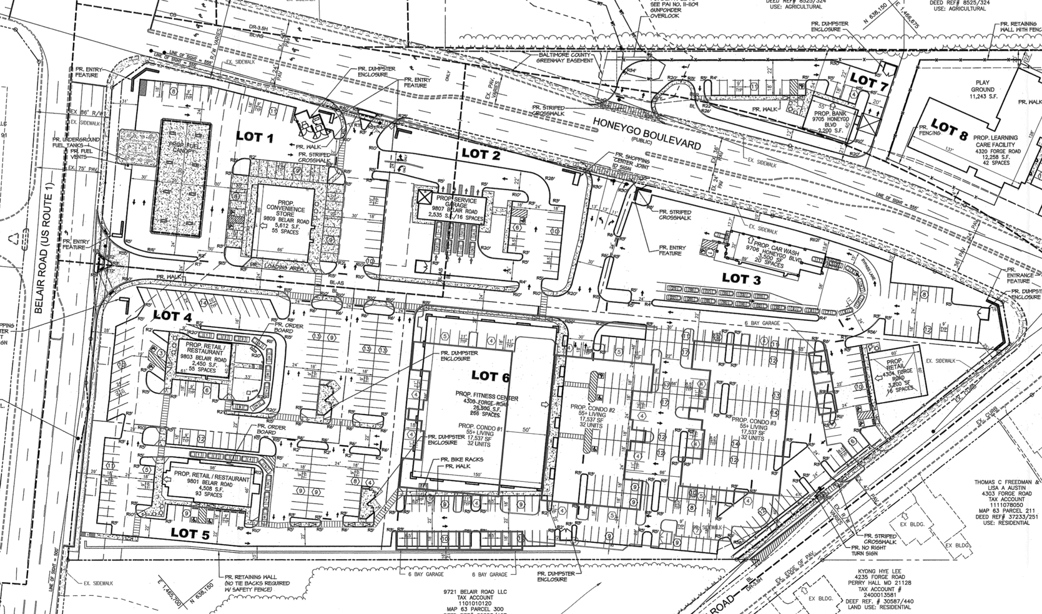
The project as proposed by Southern Land has a limited, perhaps non-existent, impact on the schools. The project as proposed will develop on a piece of a property that has been vacant for some time with now a mixture of residential and commercial uses. There is currently an overabundance of commercial in the area, which when coupled with current COVID restrictions lends itself to the inclusion of age restricted residential development which will not impact schools and will support local business.

The PHIA SUPPORTS the DRC request and the concept as presented. Some concerns that could be addressed if the project moves forward include the following.

- The overall development is somewhat haphazard. By adding the residential development to an already approved site, the developer has not really addressed the integration of the commercial with the residential uses. There is a lack of even small open space, and a lack of pedestrian connectivity within the project.

- A safe pedestrian crossing on Honeygo Blvd. between Cross Road and Forge Road should be provided for safe access for pedestrians going between Perry Hall Park and Perry Hall Library.

- Traffic at the intersection of Honeygo Blvd. and Cross Road needs to be addressed. There has been some discussion for several years about whether a light or a roundabout would be beneficial.

- The current development review and approval process is inherently flawed in situations such as these. Rather than look at the development piecemeal with the forgone conclusion that the commercial has already been approved and therefore not subject
to change essentially prohibits any good site design. The era of pad site strip commercial seems to linger and flourish while the creation of neighborhood centers like the Honeygo Village Center are hard to come by. The PHIA realizes that this issue is outside the scope of this request, however it bears note.

If you require any information or assistance please feel free to contact me at pkeller57@verizon.net.

Sincerely,

Pat Keller, PHIA Sustainable Growth Committee

PHIA Board Members

Jack Amrhein
Tom Benisch
Renee Papavasiliou
Kevin Leary
Salim Barrouck

