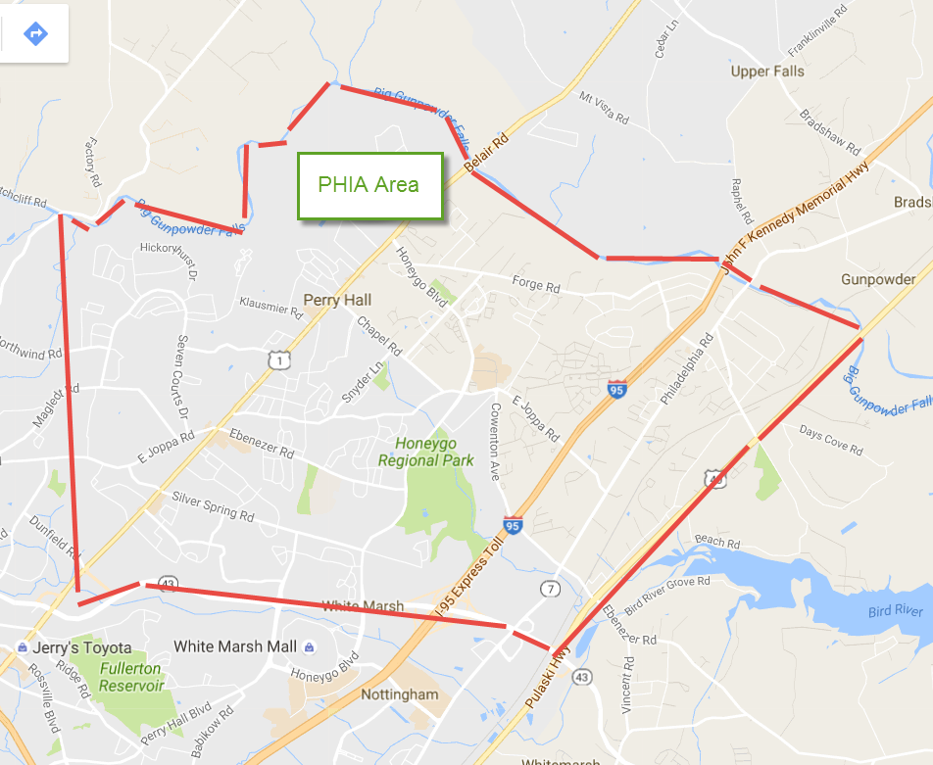
PHIA Association Boundaries – General Map 8-12-2016

