Welcome To Perry Hall – Signs
4/7/21

- Southbound Belair Road at Gunpowder – just south of Gunpowder Lodge

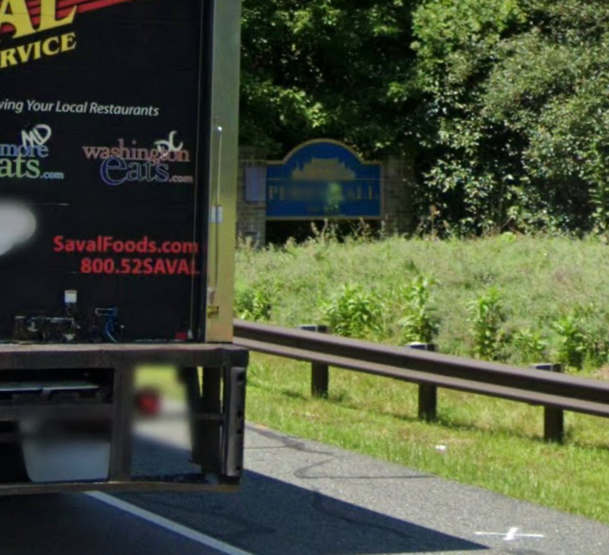

- Eastbound Joppa Road Just Past All American Steakhouse

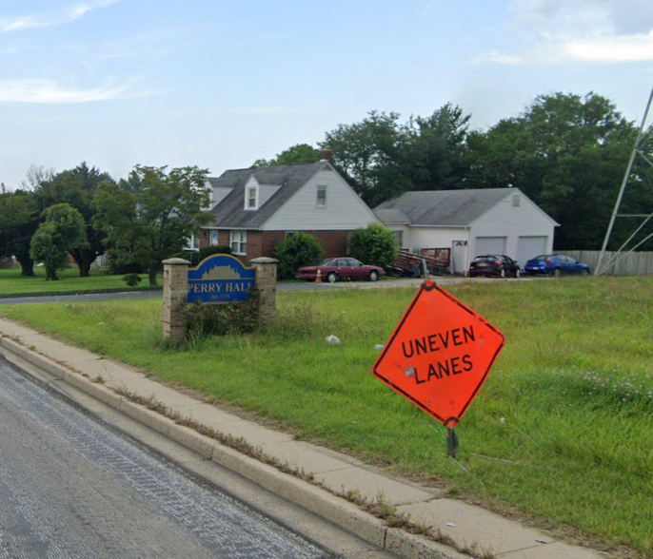

- Perry Hall Elementary School

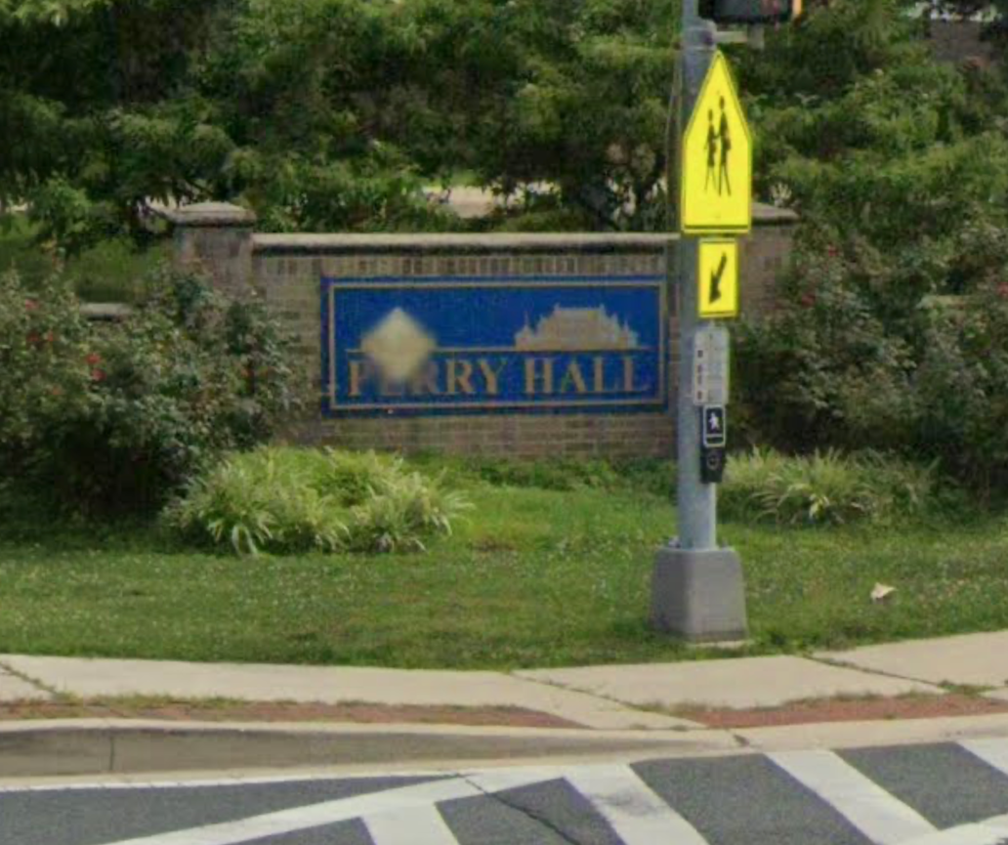

- Old Forge Lane – Old Forge Apartments

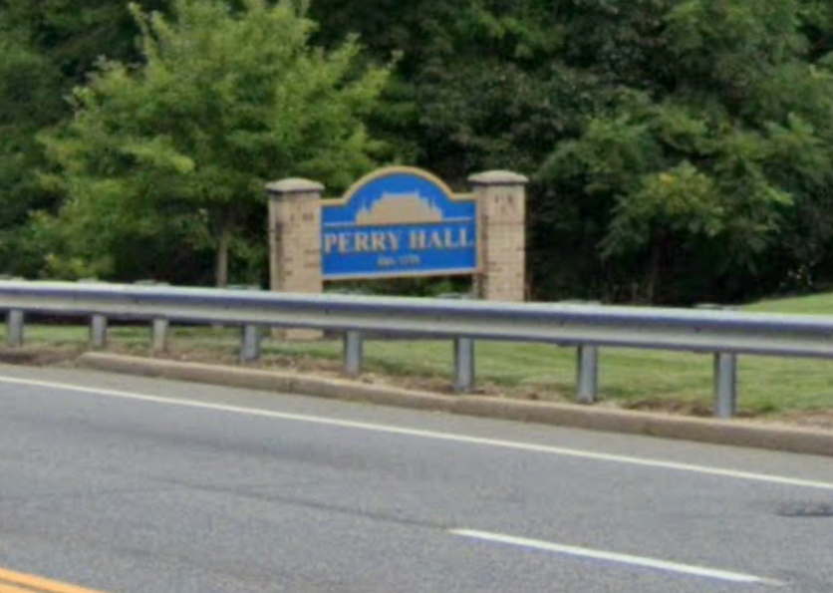

- Casa Mias

