Magnolia PUD
PHIA Comments 2/17/2021

The Perry Hall Improvement Association (PHIA) has been following the Magnolia PUD as approved for further review via Resolution 112-20 by the County Council. The PHIA is appalled at the density increase from existing zoning DR 1 which allows 10 dwelling units on the parcel to the PUD DR 5.8 which provides 58 dwelling units on the parcel. This property has NEVER been zoned for this many dwelling units in its whole history.

Based upon the PHIA analysis of existing law and the proposed plan, the PHIA respectfully submits the following.

Master Plan Conflict
The PHIA is of the opinion that the proposed PUD is in conflict with Baltimore Master Plan 2020.

Rationale for this request is based upon the following.

- Baltimore Master Plan 2020 - The County designation of the PUD area is Community Conservation (pages 39 – 62, Baltimore County Master Plan 2020). Key policies include supporting existing communities with adequate infrastructure (schools, roads, parks, water, sewer, police, fire etc.). Clearly, the proposed Magnolia PUD is not in keeping with these policies.

- Baltimore County Master Plan 2020 – The County designated this area ‘Proposed Land use’ page 28 as T3 Sub-Urban. Page 30 provides the following.

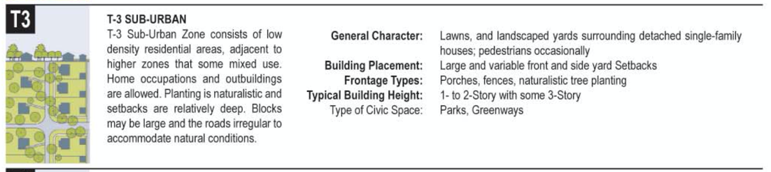

- Gross Violation of Existing Zoning – The surrounding community area is now largely developed. Between 1971 and 1996 when the area was designated as a Growth Area, the zoning for this site was DR 5.5. Between 2000 and 2008 when the area was still designated as a growth area the zoning for the site was DR 3.5. Since 2012 and up to today 2021 the site has been zoned DR 1 when the area was changed to a Community Conservation Area. All of the existing townhouse development in the area was developed at DR 5.5 or DR 3.5 density, the proposed Magnolia PUD is proposed at DR 5.8 density.

The site has never zoned for the density being proposed in this PUD.

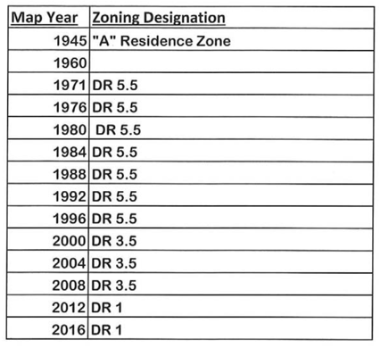

The Baltimore County, Department of Planning provided the following Concept Plan
Comment, further supporting the PHIA’s contention that the PUD plan constitutes a
Master Plan Conflict.

- “Master Plan 2020 outlines many goals and policies to ensure that the development of land in Baltimore County has been thoughtfully and holistically considered. Having a high quality public realm, pedestrian friendly street design, an interconnected street network, high-quality community design and architecture that create human comfort and a sense of place, in addition to providing open spaces to serve as focal points and informal gathering areas are all key elements of a positive PUD proposal. The proposed design pushes the open spaces to the perimeters of the site and establishes an insulated, self-serving design lacking vehicular or pedestrian connectivity to adjacent communities. Although it is stated in the submitted pattern book, it is not clear how the proposal will provide “more pedestrian-friendly” design. The majority pattern of residential development within the delineated neighborhood as provided in the PUD pattern book (page 20) demonstrates that the area is single family detached homes which both the Master Plan 2020 transect designation and existing zoning classification establish. The architectural and site design are vehicle dominant wherein which the front entry 2-car garage and driveway constitute the majority of the buildings’ facades of the 24’ wide unit and the 22’ wide paving width and minimized front building setbacks create a congested development with standard width sidewalks and landscape strips that do not go beyond conventional development standards. More study and analysis should be given to these elements listed throughout this report so as to justify that the PUD is of a higher quality and is in conformance with Master Plan 2020.

Conflict With Zoning Regulations

Section 430.3.C of the BCZR declares that PUD density may not exceed that of the underlying zone. In passing Resolution 112-20, County Council enabled the plan to proceed through the county review process establishing a density that is significantly above the underlying zoning class of DR 1. While BCC §32-4-242(d) states that Council can modify densities or uses, it is silent as to what limit. Therefore based on BZCR §600.1 wherein which the “Interpretation of Provisions...” explains that the BCZR provisions shall control all others. The PHIA is of the opinion that the density for this PUD is not appropriate and should not be approved.

Compatibility

§ 32-4-243. - REQUIREMENTS FOR A PLANNED UNIT DEVELOPMENT.

3. How the Planned Unit Development will comply with the compatibility requirements of § 32-4-402 of this title;

§ 32-4-402.1. - PLANNED UNIT DEVELOPMENT - COMPATIBILITY.
(a) Recommendations by Director of Planning. The Director of Planning shall make compatibility recommendations to the Hearing Officer for a Planned Unit Development, which, in whole or in part, is:
(1) Located in a Baltimore County Commercial Revitalization District;
(2) Identified within a Transect Overlay of T-6 in the Master Plan (Map 5);
(3) A Brownfields site as defined in § 5-301 of the Economic Development Article of the Annotated Code of Maryland;
(4) An approved transit oriented development opportunity site; or
(5) Identified within a Transect Overlay of T-5 in the Master Plan (Map 5), located in an area identified in the Master Plan as a Community Enhancement Area (Map 6), and adjacent to an interstate highway.
(b) Compatibility objectives. The development of a Planned Unit Development listed in subsection (a) shall be designed to substantially comply with the following compatibility objectives so that the development:
(1) Is in a location that is significant due to its visibility, accessibility or siting;
(2) Has or will provide adequate public infrastructure;
(3) Provides compact development;
(4) Provides sustainable design;
(5) Encourages new investment or reinvestment opportunities;
(6) Fosters development or redevelopment of well-located but under-utilized or obsolete properties;
(7) Provides economic benefits;
(8) Demonstrates that its buildings, parking structures, landscaping, open space patterns, signage and other architectural treatments are spatially and visually integrated within the development and incorporate appropriate elements of urban design;
(9) Connects proposed streets with the existing neighborhood road network, if practicable, and locates proposed sidewalks to support the functional patterns of the neighborhood;
(10) Integrates locally significant features of the site such as distinctive buildings or vistas into the site design; and
(11) Supports a uniform architectural theme in its exterior signs, site lighting and accessory structures.

School Capacity

Existing School Overcrowding – As more fully described within this document, all of the elementary schools within the cluster area are between 101.57% to 120.5% over capacity. All but one elementary school has between 1 to 8 relocatables on site. The average number of relocatables per school is 4.5.

Perry Hall Middle School is at 117.06% of capacity with 232 students over the State Rated Capacity.

No development should be approved until the school overcrowding issues are addressed (schools under construction).

§ 32-4-215. - CONFLICT WITH MASTER PLAN.

(a) Referral to Planning Board. If a conflict between the Master Plan and the concept plan is identified, the concept plan shall be immediately transmitted to the Planning Board in accordance with § 32-4-231 of this subtitle.
(b) Continuation of process. A concept plan identified under subsection (a) of this section as being in conflict with the Master Plan may continue to be reviewed and processed under these development regulations.

